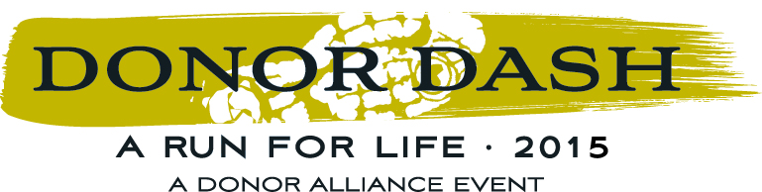

2015 Donor Dash – PSA Scripts

PSA Copy – Feel free to customize this with your network/business/hospital’s name for any radio PSAs, or to use on internal AV systems

Scripts:

:15
Voice over: Let’s lace up our sneakers and go on a run that celebrates life! The 2015 Donor Dash takes place on Sunday, July 19th at Washington Park! Honor those who’ve received and given a gift of life! Join (INSERT YOUR NETWORK / BUSINESS / HOSPITAL NAME) and say yes to organ, eye and tissue donation. The Donor Dash! Register today at DonorAlliance.org/DonorDash!

:30
Voice over: Let’s lace up our sneakers and go on a run that celebrates life at the 2015 Donor Dash! Join (INSERT YOUR NETWORK / BUSINESS / HOSPITAL NAME) Sunday, July 19th at Washington Park! The 5K walk / run honors organ, eye and tissue donors while celebrating recipients of life saving transplants. Say yes to organ, eye and tissue donation and pledge your support to thousands of Coloradans still waiting for a transplant. The Donor Dash! A run for life! Register today at DonorAlliance.org/DonorDash!

Donor Alliance is happy to provide graphics to complement the above scripts, should you care to use them on a video screen, etc. Please contact John Romero at jromero@donoralliance.org for more assistance.

