Jillian
Donor Daughter
Cheyenne, WY

In November 2013, my mother, Audrey Veronica Gava, passed away suddenly as the result of a ruptured brain aneurysm.

My mother spent over twenty years serving as a foster mother for abused and neglected children, before becoming a full-time nanny for a special needs child. Audrey was a natural caretaker, extraordinary mother, eldest sister of five, aunt, and friend to everyone she met. She always put the needs of others ahead of her own. She also treated each foster child who entered her home just as they were her own.

My mother had an infectious laugh and smile, and never forgot anyone’s birthday, anniversary, or special event, something that always impressed me. I would actually look forward to her almost weekly calls reminding me to call a family member or friend to wish them a happy birthday.

Because my mother was always taking care of others in life, my brother and I believed organ, tissue and eye donation was the only option for our mother in death. The idea that my mother’s death could be the miracle another family was waiting for gave my mother’s death meaning, and helped us with the grieving process. I don’t believe she would wanted it any other way, as she always told me she wanted her death to be a celebration of life.

Because of the work and support of Donate Life Nevada, and the great staff at Spring Valley Hospital Medical Center, my mother was able to donate both her lungs to a 19 year old female, her liver and both her kidneys. One of her kidneys went to a mother, who without organ donation, might not have been able to see her daughter graduate high school or someday get to feel the joy of being a grandmother, something my mother missed out on.

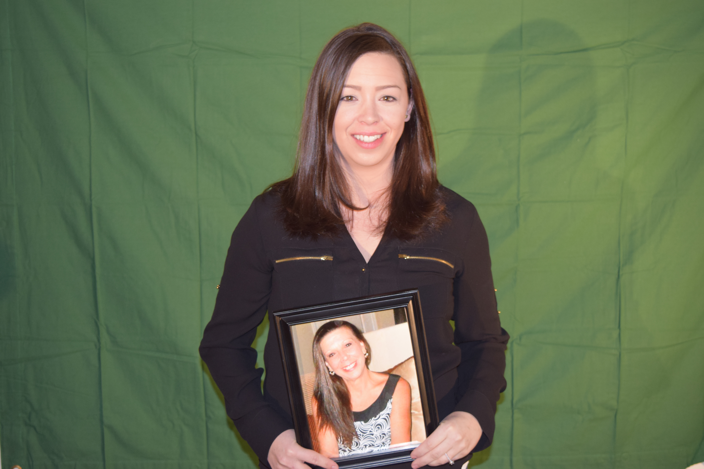
Jillian and her mother, Audrey

