Juniper
Heart Recipient
Denver, CO

It was a joyous day in February of 2014 when little Juniper was welcomed into the world. But for parents Cole Gelrod and Joni Schrantz, that joy quickly turned to worry when - at only two weeks old - their first-born child was diagnosed with total heart failure. Juniper was born with dilated cardiomyopathy, and her heart pumped blood through her tiny body at only one-sixth the normal rate.

Her only hope for survival was a heart transplant.

In order to survive long enough for a transplant, Juniper became the youngest patient at Children's Hospital Colorado to be placed on a surgically attached device called a Berlin Heart. The 200-pound machine would pump blood through her body until a heart became available.

After five months on the pump, a heart did become available and Juniper successfully received it on Sept. 17. She was just seven months old.

Juniper's mom, Joni, is keenly aware of the sacrifice that makes her daughter's life possible. She looks forward to thanking the parents of Juniper's donor when the time is right.

"The gratitude felt is almost indescribable," she said. "I would want them to know that we plan on honoring their gift by taking amazing care of Juniper's heart and by giving her a wonderful life. We almost see it like she is living for the both of them because she wouldn't be here without their child."

Now three years old, Juniper has become an adventurous and feisty child. "She's strong minded, which is good," Joni said. "She needed some fight in her to get through her first year of life."

Juniper's first birthday was fittingly celebrated with a heart-themed party on Valentine's Day.

"Her birthday was especially emotional for me in a lot of ways," Joni shared. "I was not aware of her heart condition when she was born, so when I think back to those first two weeks of her life and what was in store for us, it's still a little raw. On the flip side, I didn't think she'd make it to her first birthday, so I felt so grateful to be celebrating it."

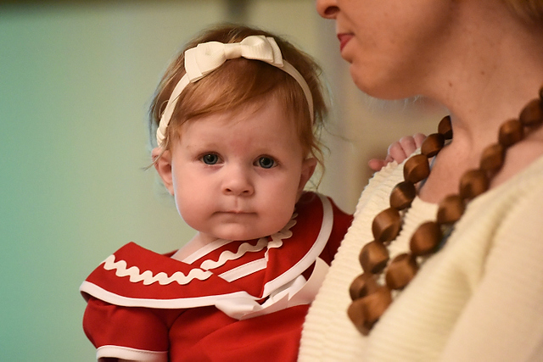
Juniper and family Juniper

