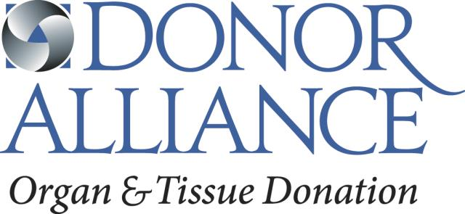

FAIR CREDIT REPORTING ACT
DISCLOSURE REGARDING BACKGROUND INVESTIGATION

As an applicant for volunteer position or a current volunteer of Donor Alliance, Inc., you are a consumer with rights under the Fair Credit Reporting Act. In the event any of the following circumstances exist, Donor Alliance, Inc. may choose to obtain and use information contained in either a consumer report or an investigative consumer report from a consumer reporting agency about you when: (1) considering your application for a volunteer position, (2) making a decision whether to offer you a volunteer position, (3) deciding whether to continue your volunteer position, or (4) making other volunteer-related decisions directly affecting you.
Our consumer reporting agency is Employers Council. at PO Box 539, Denver, CO 80201, toll free 800.884.1328, which, for monetary fees, dues, or on a cooperative nonprofit basis, regularly assembles or evaluates consumer information on consumers for the purpose of furnishing consumer reports to others, such as Donor Alliance, Inc.
A consumer report means any written, oral or other communication of any information by a consumer reporting agency bearing on your character, general reputation, personal characteristics, or mode of living which is used or expected to be used or collected in whole or in part for the purpose of serving as a factor in establishing your eligibility for employment purposes.
An investigative consumer report means a consumer report or portion thereof in which information on your character, general reputation, personal characteristics, or mode of living is obtained through personal interviews with your neighbors, friends, or associates reported on or with others with whom you are acquainted or who may have knowledge concerning any such items of information.
In the event an investigative consumer report is prepared, you may request additional disclosures regarding the nature and scope of the investigation requested as well as a written summary of your rights under the Fair Credit Reporting Act.

AUTHORIZATION REGARDING BACKGROUND INVESTIGATION

I acknowledge receipt of the DISCLOSURE REGARDING BACKGROUND INVESTIGATION and A SUMMARY OF YOUR RIGHTS UNDER THE FAIR CREDIT REPORTING ACT and certify that I have read and understand both of these documents.

Donor Alliance, Inc. ("the Company") may obtain information about you for volunteer opportunity purposes from the following consumer reporting agency ("the Agency"), Mountain States Employers Council, Inc., PO Box 539, Denver, CO 80201, toll free 800-884-1328.

By signing below, I hereby voluntarily authorize Donor Alliance, Inc., to obtain either a consumer report or an investigative consumer report about me from a consumer reporting agency and to consider this information when making decisions regarding my volunteer opportunities at Donor Alliance, Inc. I understand that I have rights under the Fair Credit Reporting Act, including the rights discussed above.

I voluntarily authorize all persons, including current and former employers and supervisors, educational institutions, law enforcement agencies, motor vehicle departments, and municipal, state, and federal courts to release information they may have about me to Donor Alliance, Inc. I understand that if I volunteer with Donor Alliance, Inc., this authorization shall remain in effect throughout my volunteer position. This report may be delivered in either written or electronic form.

California applicants or employees only:
Please check this box if you would like to receive a copy of an investigative consumer report at no charge if one is obtained by the Company whenever you have a right to receive such a copy under California law. By signing below you also acknowledge receipt of the NOTICE REGARDING BACKGROUND INVESTIGATION PURSUANT TO CALIFORNIA LAW.
Massachusetts, and New Jersey applicants or employees only:
You have the right to inspect and promptly receive a copy of any investigative consumer report requested by the Company by contacting the consumer reporting agency identified above directly.
Minnesota applicants or employees only:
You have the right, upon written request to the Agency, to receive a complete and accurate disclosure of the nature and scope of any consumer report. The Agency must make this disclosure within five days of receipt of your request or of the Company's request for the report, whichever is later. Please check the box if you would like to receive a copy of a consumer report if one is obtained by the Company.
New York applicants or employees only:
You have the right to inspect and receive a copy of any investigative consumer report requested by the Company by contacting the consumer reporting agency identified above directly. By signing below, you also acknowledge receipt of Article 23-A of the New York Correction Law.
Oklahoma applicants or employees only:
Please check this box if you would like to receive a copy of any report if one is obtained by the Company.
Pennsylvania applicants or employees only:
By signing below you acknowledge that consideration of a criminal record will be tailored to the requirements of the job.
Washington applicants or employees only:
You have the right to receive a complete and accurate disclosure of the nature and scope of any investigative consumer report as well as a written summary of your rights and remedies under Washington law.

_______________________________________________
Signature Date
_______________________________________________ __________________________
Printed Name Email Address
_______________________________________________ __________________________
Social Security Number Date of Birth

Additionally, please provide 7 years of address history (if necessary, please use an additional sheet of paper):

_____________________________________________________________________________________________________
Street Address City State Zip Move in date

