Dana – Colorado Springs, Colorado
Donor Alliance

Dana’s Story
Waitlist Candidate Daughter

When Dana was 12 years old, she moved to Colorado with her mother and her step-father, Al Lucero. Throughout her life, Al (or Mr. Al as Dana affectionately calls him, has been so much more than just a step-father to her. Al never missed a school conference. He was always there to help her with homework and even made sure she had proper celebrations for both her high school and college graduation celebration. Now days, many people in Southern Colorado may recognize Al as Santa, as he dresses up every Christmas season for kids in schools all over Southern Colorado.”

Al’s love of his country has always been apparent. He proudly served in the United States Army during the Vietnam War. Due to injuries suffered during his time in Vietnam, Al became sicker and sicker and was eventually diagnosed with full blown kidney failure. For the past three years, Al has been forced to undergo dialysis treatments multiple times a week to keep him alive. Al is currently listed on the kidney transplant waiting list, but his wait continues.

As Al was placed on the transplant waiting list, Dana began the process of testing to be a living kidney donor for her step-father. Sadly, Dana and other family members are not viable living donors and thus began their search for a living donor for Al.

Dana has made it her personal mission to not only advocate for her step-father’s transplant, but to also bring awareness to the need for donation and transplantation in Southern Colorado. “My step-father has always had a passion for serving others.” Dana says, “He was a school counselor and educator for many years. He primarily sought lower socioeconomic schools to service as he knew this is where he would have the most impact. Even now he continues to support the community by volunteering for toy drives and dressing up as Santa for local schools. I just want Mr. Al to have a chance to be healthy for himself and his family who loves him with all of our hearts.”

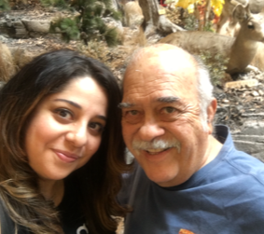
Dana and Al Lucero

