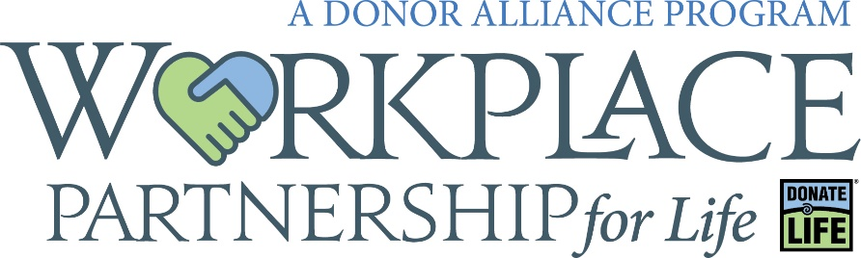

Social Media Info and Sample Posts

Sample Social Media Posts

Right now nearly 2,000 people in our communities are waiting for a lifesaving transplant. Be someone’s hero and say Yes to organ, eye and tissue donation at the driver license office or online at (select one - DonateLifeColorado.org / DonateLifeWyoming.org)

Organ, eye and tissue donation saves and heals lives! Sign up as an organ, eye and tissue donor at the driver license office or online at (select one - DonateLifeColorado.org / DonateLifeWyoming.org)

Heroes say Yes to organ, eye and tissue donation! Join (insert business name here) and (insert our social media tag here) to help raise awareness for the nearly 2,000 people in our communities who are waiting for a lifesaving transplant! Learn more and sign up today at (select one - DonateLifeColorado.org / DonateLifeWyoming.org)

All of us at (insert business name here) are proud to support (insert our social media tag here) by being a valued Workplace Partnership for Life Partner. Did you know that just one person can save 8 lives through organ donation and heal more than 75 through tissue donation? Help us spread awareness for the nearly 2,000 people in our communities who are waiting for a lifesaving transplant! Learn more about becoming a workplace partner here: (insert URL - https://www.donoralliance.org/get-involved/outreach-programs/workplace-partnership-for-life/)

Websites

Donor Alliance: www.DonorAlliance.org
Donate Life Colorado: www.DonateLifeColorado.org
Donate Life Wyoming: www.DonateLifeWyoming.org

Social Media Accounts

Donate Life Colorado
Facebook: @DonateLifeColorado
Twitter: @DonateLifeCO
Instagram: @DonateLifeCO

Donate Life Wyoming
Facebook: @DonateLifeWyoming
Twitter: @DonateLifeWY
Instagram: @DonateLifeWY

Done Vida Colorado
Facebook: @DoneVidaColorado

Donor Alliance
LinkedIn: Donor Alliance

