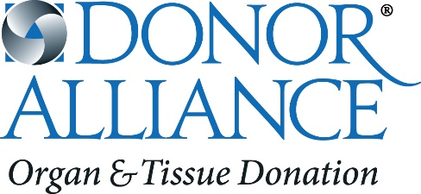

2019 Donor Alliance Fact Sheet

Donor Alliance is the federally designated, Association of Organ Procurement Organizations (AOPO) and American Association of Tissue Banks (AATB) accredited, non-profit organ procurement organization and tissue bank serving Colorado and most of Wyoming. As a recognized leader in facilitating the donation and recovery of transplantable organs and tissues, Donor Alliance’s mission is to save lives through organ and tissue donation and transplantation.

To achieve this mission, Donor Alliance employs effective family approach and recovery programs in 110 hospitals. Donor Alliance also inspires the public to register as organ and tissue donors through community partnerships, public outreach and education campaigns throughout our donation service area.

Vision Statement: Donor Alliances strives to maximize all donation opportunities.
Fast Facts about Organ and Tissue Donation:
Local stats:
- In Colorado and Wyoming 1,989 people are currently waiting for a lifesaving organ transplant.
- 69% of Coloradans and 60% of Wyomingites are registered organ, eye and tissue donors.
- Of those waiting, 1,540 are waiting for a kidney—the organ most in need (77%)—and 378 are waiting for a liver (19%).
- 15% of current transplant candidates in Colorado have been on the waiting list for 5 years or more.
- 28% of those waiting for an organ transplant are under 50 years of age; another 43% are between 50 and 64.
- Colorado has one of the nation’s highest-performing state donor registries with 69% of driver’s license/ID card applicants signing up to be organ and tissue donors. Wyoming is also amongst the top 10 nationally at 60%.
- 489 people received lifesaving organ transplants in 2018 thanks to a record 160 organ donors in Colorado & Wyoming.
- Of those 160 organ donors 73% were signed up on the Donate Life Colorado or Wyoming Donor Registry.
- In 2018, Donor Alliance recovered tissue for transplant from 1,684 donors; of those, 68% were signed up on the Donate Life Colorado or Wyoming Donor Registry.
- Donor Alliance’s Donor Service Area serves six million residents and covers 184,151 square miles – this includes all of Colorado and most of Wyoming.

National stats & facts:
- Today, 113,866 people are waiting for lifesaving organ transplants nationally.
- 36,527 organ transplants were performed in the United States in 2018, setting an annual record for the sixth year.
- Of the patients waiting, 94,886 (83%) are in need of a kidney and 13,419 (12%) are in need of a liver transplant.
- Transplantable organs include the heart, lungs, liver, kidneys, pancreas and small bowel.
- Recoverable tissues include bone, tendons and corneas as well veins, valves and skin.
- One donor can save up to eight lives through organ donation and can save and heal more than 75 lives through tissue donation.
- On average, 20 people die each day while waiting for a lifesaving transplant.
- On average, 95 transplants take place each day in the United States.
- Every 10 minutes another name is added to the national transplant waiting list.
- Approximately 1.75 million tissue transplants are performed annually in the United States.
- Nearly 6,900 living donor transplants in 2018. One in four donors is not biologically related to the recipient.
To learn more about organ and tissue donation, please visit www.DonorAlliance.org or call 303-329-4747.
Residents can join the Donate Life Colorado or Wyoming Registries by visiting:
www.DonateLifeColorado.org or www.DonateLifeWyoming.org

Statistics provided by the United Network for Organ Sharing, www.unos.org & Eye Bank Association of America
Last updated: January 22, 2019 [Based on OPTN data as of January 17, 2019]

