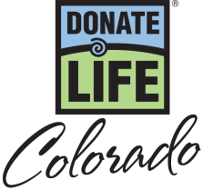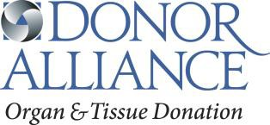

April is National Donate Life Month – Social Media Posts

April is National Donate Life Month. Do you have a heart on your driver license? Why did you make the decision to save lives by being an organ, eye and tissue donor? #ShowYourHeartCO

April is National Donate Life Month. Do you know someone who is in need of a life-saving organ transplant? More than 2,500 people right here in Colorado are waiting on a transplant. You can help by registering as an organ, eye and tissue donor at the driver license office or online at DonateLifeColorado.org. #ShowYourHeartCO

Did you know anyone can register to be an organ, eye and tissue donor regardless of health or age? Even diabetics and others with chronic diseases have the power to donate life. April is National Donate Life Month. Register as an organ, eye and tissue donor at the driver license office or online at DonateLifeColorado.org. #ShowYourHeartCO

National Donate Life Month Show Your Heart and Save Week – Social Media Posts

Celebrate Show Your Heart and Save Week! From April 15-21, show your support to Organ, Eye and Tissue Donation by showing the heart on your driver license at participating restaurants and receive special discounts. To get a list of the participating locations and learn more visit DonateLifeColorado.org/NDLM. Be Someone’s hero. Say yes to organ, eye and tissue donation. #ShowYourHeartCO

Are you a registered organ, eye and tissue donor? We want to say Thank You! From April 15-21 show the heart on your driver license at participating establishment and receive special discounts. To get a list of the participating locations and learn more visit DonateLifeColorado.org/NDLM. Be Someone’s hero. Say yes to organ, eye and tissue donation. #ShowYourHeartCO
Are you a registered organ, eye and tissue donor? Donate Life Colorado wants to say Thank You! From April 15-21 show the heart on your driver license at participating establishment and receive special discounts. To get a list of the participating locations and learn more visit DonateLifeColorado.org/NDLM. Be Someone’s hero. Say yes to organ, eye and tissue donation. #ShowYourHeartCO

NASCAR Drive Joey Gase / Denver Auto Show Social Media Posts

Show Your Heart in support of organ, eye and tissue donation during National Donate Life Month this April! Visit the Donate Life Colorado booth at the Denver Auto Show from April 5th-9th and show the heart on your driver license to place a heart stencil on NASCAR driver Joey Gase’s official racecar. Stop by on evening of Wednesday, April 5th for your chance to meet Joey! For more information visit DonateLifeColorado.org/NDLM. #ShowYourHeartCO

