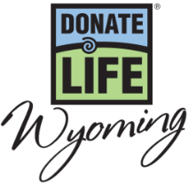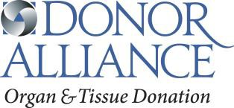

April is National Donate Life Month – Social Media Posts

April is National Donate Life Month. Do you have hearts on your driver license? Why did you make the decision to save lives by being an organ, eye and tissue donor? #ShowYourHeartWY

April is National Donate Life Month. Do you know someone who is in need of a life-saving organ transplant? Nearly 200 people right here in Wyoming are waiting on a transplant. You can help by registering as an organ, eye and tissue donor at the Driver Services office or online at DonateLifeWyoming.org. #ShowYourHeartWY

Did you know anyone can register to be an organ, eye and tissue donor regardless of health or age? Even diabetics and others with chronic diseases have the power to donate life. April is National Donate Life Month. Register as an organ, eye and tissue donor at the Driver Services office or online at DonateLifeWyoming.org. #ShowYourHeartWY

National Donate Life Month Show Your Heart and Save Week – Social Media Posts

Celebrate Show Your Heart and Save Week! From April 15-21, show your support to Organ, Eye and Tissue Donation by showing the hearts on your driver license at participating restaurants and receive special discounts. To get a list of the participating locations and learn more visit DonateLifeWyoming.org/NDLM. Be Someone’s hero. Say yes to organ, eye and tissue donation. #ShowYourHeartWY

Are you a registered organ, eye and tissue donor? We want to say Thank You! From, April 15-21 show the hearts on your driver license at participating establishment and receive special discounts. To get a list of the participating locations and learn more visit DonateLifeWyoming.org/NDLM. Be Someone’s hero. Say yes to organ, eye and tissue donation. #ShowYourHeartWY
NASCAR Driver Joey Gase / Cheyenne Appearance – Social Media Post

Show Your Heart in support of organ, eye and tissue donation during National Donate Life Month this April! Join Donate Life Wyoming on Monday, April 3rd from 5pm-7pm at the Old Chicago in Cheyenne and show the hearts on your driver license for a chance to meet NASCAR driver Joey Gase and paint a heart on his official racecar. For more information visit DonateLifeWyoming.org/NDLM. #ShowYourHeartWY

