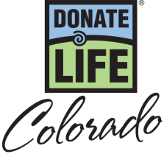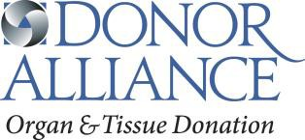

National Donate Life Month 2017 – PSA Scripts

:10 (27 words)
Show Your Heart for National Donate Life Month this April. Be someone’s Hero and show your support for organ, eye and tissue donation. Learn more at DonateLifeColorado.org/NDLM.

:15 (45 words)
Show Your Heart for National Donate Life Month this April! More than 2,500 people in Colorado continue to wait for a lifesaving transplant. Be someone’s Hero by saying Yes to organ, eye and tissue donation. Learn more on how to show your support at DonateLifeColorado.org/NDLM.

:30 (82 words)
Show Your Heart in support of organ, eye and tissue donation during National Donate Life Month this April! More than 2,500 people in Colorado continue to wait for a lifesaving transplant and anyone, regardless of age or medical condition, can register as a donor. Be someone’s Hero by saying Yes to organ, eye and tissue donation at the Driver License Office. Once you’ve registered and discussed donation with your family, you can learn more on how to show your support at DonateLifeColorado.org/NDLM.

National Donate Life Month Show Your Heart and Save Week (April 15 - 21) – PSA Copy

:10 (30 words)
Show Your Heart and Save in honor of National Donate Life Month! April 15-21, show the heart on your driver license at participating restaurants and receive discounts! Learn more at DonateLifeColorado.org/NDLM.

:15 (45 words)
Show Your Heart and Save in honor of National Donate Life Month! April 15-21, receive special discounts by showing the heart on your driver license at participating area restaurants! Be someone’s Hero. Say yes to organ, eye and tissue donation. Learn more at DonateLifeColorado.org/NDLM.

:30 (83 words)
Show Your Heart and Save in honor of National Donate Life Month! From April 15-21, show your support to the more than 2,500 people in Colorado waiting for a lifesaving transplant and receive special discounts. Show the heart on your driver license at participating area restaurants or wear blue and green in celebration of National Donate Life Month. Be someone’s Hero. Say yes to organ, eye and tissue donation. For more details and to learn how you can be someone’s hero visit DonateLifeColorado.org/NDLM.

NASCAR Driver Joey Gase / Denver Auto Show – PSA Copy

:10 (30 words)
April is National Donate Life Month. Show Your Heart for a chance to meet NASCAR driver Joey Gase at the Denver Auto Show. Learn more at DonateLifeColorado.org/NDLM.

:15 (45 words)
Show Your Heart for National Donate Life Month this April! Visit the Donate Life Colorado booth at the Denver Auto Show and show the heart on your license for a chance to meet NASCAR driver Joey Gase and paint a heart on his official racecar. For more information visit DonateLifeColorado.org/NDLM.

:30 (90 words)
Show Your Heart in support of organ, eye and tissue donation during National Donate Life Month this April! Stop by the Donate Life Colorado booth at the Denver Auto Show on April 5th and show the heart on your driver license for a chance to meet NASCAR driver Joey Gase and paint a heart on his official racecar. For additional event details and further information on how you can help the more than 2,500 people in Colorado waiting for a lifesaving organ transplant visit DonateLifeColorado.org/NDLM.

