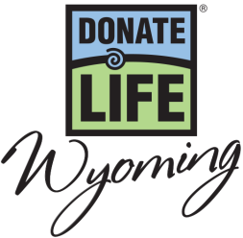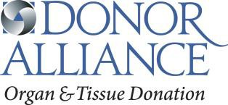

National Donate Life Month 2017 – PSA Scripts

:10 (27 words)
Show Your Heart for National Donate Life Month this April. Be someone’s Hero and show your support for organ, eye and tissue donation. Learn more at DonateLifeWyoming.org/NDLM.

:15 (45 words)
Show Your Heart for National Donate Life Month this April! Nearly 200 people in Wyoming continue to wait for a lifesaving transplant. Be someone’s Hero by saying Yes to organ, eye and tissue donation. Learn more on how to show your support at DonateLifeWyoming.org/NDLM.

:30 (81 words)
Show Your Heart in support of organ, eye and tissue donation during National Donate Life Month this April! Nearly 200 people in Wyoming continue to wait for a lifesaving transplant and anyone, regardless of age or medical condition, can register as a donor. Be someone’s Hero by saying Yes to organ, eye and tissue donation at the Driver Services Office. Once you’ve registered and discussed donation with your family, you can learn more on how to show your support at DonateLifeWyoming.org/NDLM.

National Donate Life Month Show Your Heart and Save Week (April 15 - 21) – PSA Copy

:10 (30 words)
Show Your Heart and Save in honor of National Donate Life Month! April 15-21, show the hearts on your driver license at participating restaurants and receive discounts! Learn more at DonateLifeWyoming.org/NDLM

:15 (45 words)
Show Your Heart and Save in honor of National Donate Life Month! April 15-21, receive special discounts by showing the hearts on your driver license at participating area restaurants! Be someone’s Hero. Say yes to organ, eye and tissue donation. Learn more at DonateLifeWyoming.org/NDLM

:30 (82 words)
Show Your Heart and Save in honor of National Donate Life Month! From April 15-21, show your support to the nearly 200 people in Wyoming waiting for a lifesaving transplant and receive special discounts. Show the hearts on your driver license at participating area restaurants or wear blue and green in celebration of National Donate Life Month. Be someone’s Hero. Say yes to organ, eye and tissue donation. For more details and to learn how you can be someone’s hero visit DonateLifeWyoming.org/NDLM.

NASCAR Driver Joey Gase Old Chicago Cheyenne Appearance – PSA Copy

:10 (30 words)
April is National Donate Life Month. Show Your Heart for a chance to meet NASCAR driver Joey Gase on April 3rd at Old Chicago in Cheyenne. Learn more at DonateLifeWyoming.org/NDLM.

:15 (45 words)
Show Your Heart for National Donate Life Month this April! Stop by the Old Chicago in Cheyenne on April 3rd and show the hearts on your license for a chance to meet NASCAR driver Joey Gase and paint a heart on his official racecar. For more information visit DonateLifeWyoming.org/NDLM.

:30 (85 words)
Show Your Heart in support of organ, eye and tissue donation during National Donate Life Month this April! Join Donate Life Wyoming on Monday, April 3rd from 5pm-7pm at the Old Chicago in Cheyenne and show the hearts on your driver license for a chance to meet NASCAR driver Joey Gase and paint a heart on his official racecar. For additional event details and more information on how you can help the nearly 200 people in Wyoming waiting for a lifesaving organ transplant visit DonateLifeWyoming.org/NDLM.

