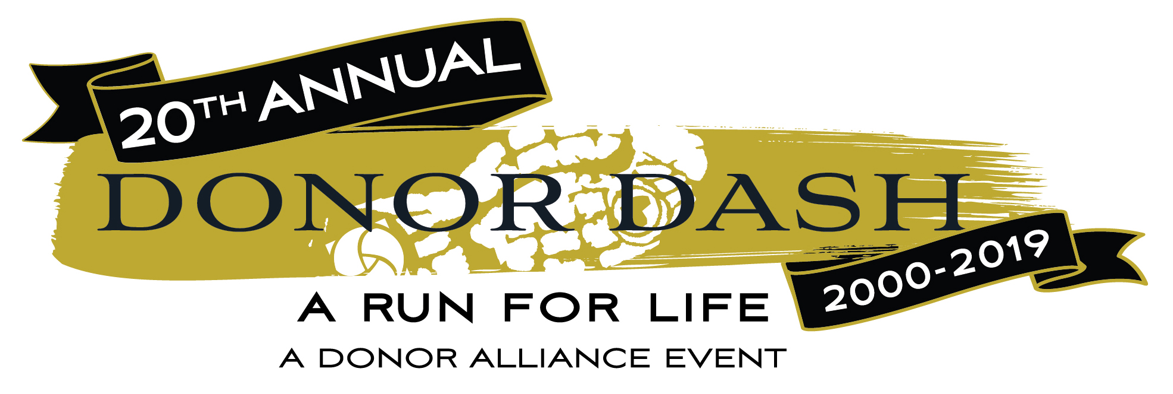

It’s time to lace up those sneakers and go on a run that celebrates life at the 2019 Donor Dash. The 20th annual Donor Dash 5K run / walk hosted by Donor Alliance, the federally designated non-profit organization that facilitates organ and tissue donation in Colorado and most of Wyoming, returns to Denver’s Washington Park on Sunday, July 21st at 8AM.

As the mountain west’s largest donation and transplantation related event, the Donor Dash brings together people of all ages to honor the lives of organ, eye and tissue donors, celebrate the lives of organ, eye and tissue recipients and recognize those who continue to wait for a lifesaving transplant. Currently, nearly 2,000 people right here in Colorado are waiting for a life-saving organ transplant.

In addition to the 5K run/walk, the Donor Dash features live entertainment, giveaways, exhibitors, a large children’s play area and even a Diaper Dash for kids 3 years old and under!

Join thousands of your fellow Coloradan’s who have said Yes to organ, eye and tissue donation at the 2019 Donor Dash! Register your team or as an individual today at www.DonorAlliance.org/DonorDash!

Donor Dash Schedule of Events (7/21/19):
7:00 AM – Race Day Registration/Packet Pickup
8:00 AM – Expo Area Opens
8:00 AM – 5K Runners Start
8:05 AM – 5K Walkers Start
9:15 AM – Diaper Dash – Expo Area (ages 3 and under) – Free
9:30 AM – Recognition Ceremony
10:00 AM – Conclusion of Ceremony

