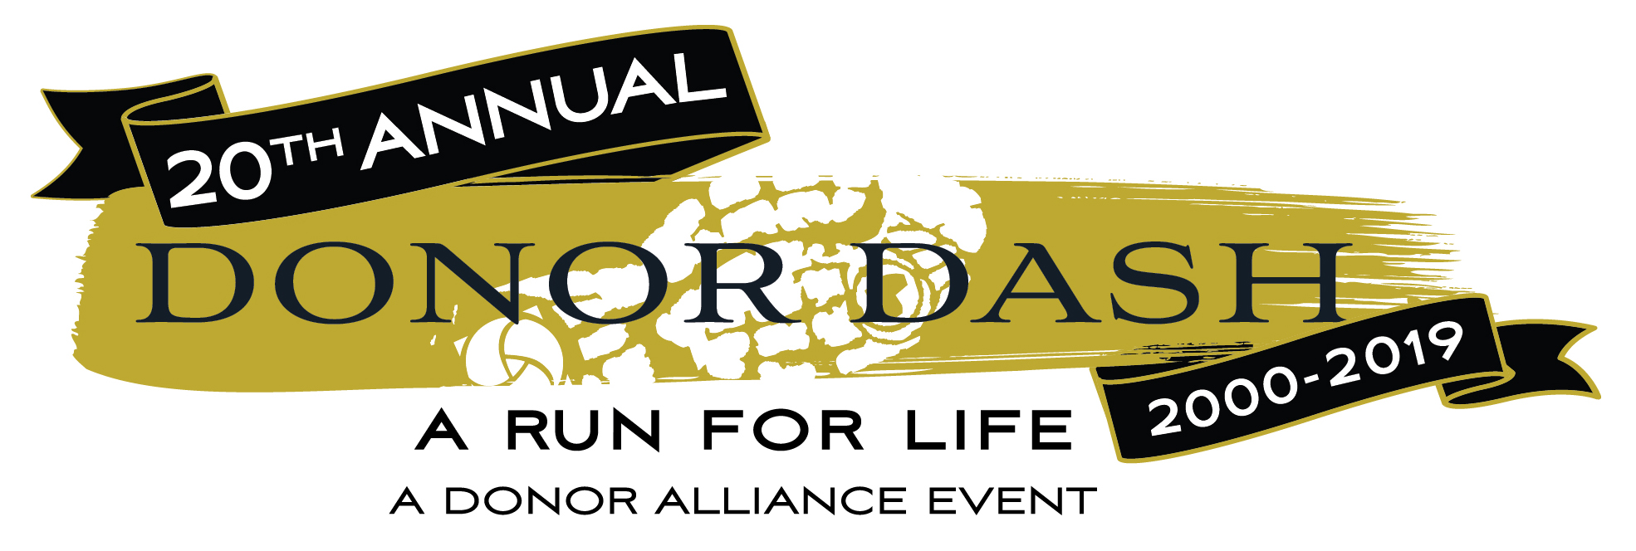

2019 Donor Dash – PSA Scripts

PSA Copy – Feel free to customize this with your network/business/hospital’s name for any radio PSAs, or to use on internal AV systems

Scripts:

:15

Voice over: Go for a run that celebrates life! Donor Dash, Sunday, July 21st in Denver’s Washington Park! Join thousands who say Yes to organ, eye and tissue donation and honor those who’ve given and received the gift of life! Who are you dashing for?! The Donor Dash! DonorAlliance.org/DonorDash!

:30

Voice over: Time to lace up our sneakers and go on a run that celebrates life at the 2019 Donor Dash - Sunday, July 21st in Denver’s Washington Park! The 5K run/walk honors organ, eye and tissue donors while celebrating recipients of lifesaving transplants. Say Yes to organ, eye and tissue donation and pledge your support to thousands of Coloradans still waiting for a transplant. The Donor Dash! A run for life! Who are you dashing for?! Register today at DonorAlliance.org/DonorDash!

Voice over: Time to lace up your sneakers and go on a run that celebrates life! The 2018 Donor Dash - Sunday, July 21st in Denver’s Washington Park! The 5K run/walk honors organ, eye and tissue donors while celebrating recipients of life saving transplants. Say Yes to organ, eye and tissue donation and pledge your support to thousands of Coloradans still waiting for a lifesaving transplant. The Donor Dash! A run for life! Who are you Dashing for?! Register at DonorAlliance.org/DonorDash!

Donor Alliance is happy to provide graphics to complement the above scripts, should you care to use them on a video screen, etc. Please contact Brianna DiPilato at bdiplilato@donoralliance.org for more assistance.

