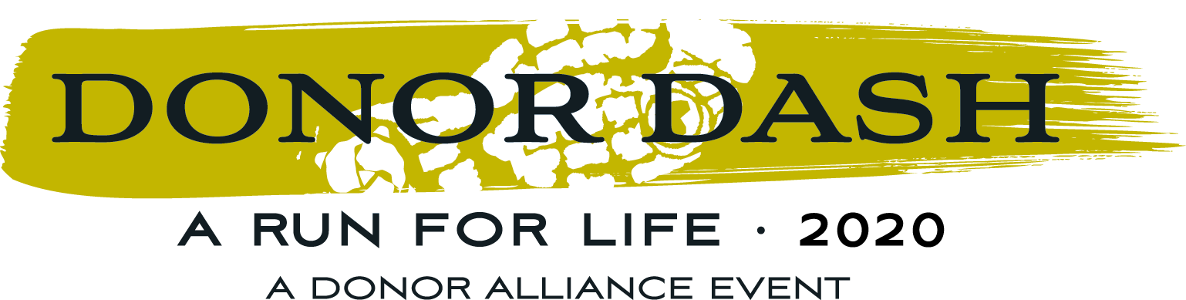

2020 Donor Dash – PSA Scripts

PSA Copy – Feel free to customize this with your network/business/hospital’s name for any radio PSAs, or to use on internal AV systems

Scripts:

:15

Join the 21st Annual Donor Dash…Together, Though Apart! Support organ, eye and tissue donation from wherever you are during a week-long event leading up to the virtual run for life on July 19th! Who are YOU dashing for? Register, today! at donor alliance dot org slash donor dash
:30

Voice over: Join the 21st Annual Donor Dash…Together, Though Apart! This year - honor, celebrate and recognize those touched by organ, eye and tissue donation and transplantation…from wherever you are! Join us for a meaninful week-long event leading up to the virtual run for life on July 19. Show your support for Organ eye and tissue donation and tell us Who YOU’re dashing for during DOnor Dash week! Learn more and Register, today! at donor alliance dot org slash donor dash. Who are YOU dashing for?

Donor Alliance is happy to provide graphics to complement the above scripts, should you care to use them on a video screen, etc. Please contact Angelica Barajas at abarajas@donoralliance.org for more assistance.

