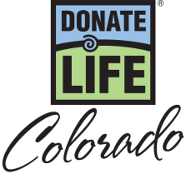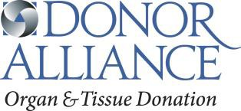

National Donate Life Month 2018 – General PSA Scripts

:10 (27 words)
Show Your Heart for National Donate Life Month this April. Be someone’s Hero and show your support for organ, eye and tissue donation. Learn more at DonateLifeColorado.org/ShowYourHeart.

:15 (45 words)
Show Your Heart for National Donate Life Month this April! Nearly 2,500 people in Colorado continue to wait for a lifesaving transplant. Be someone’s Hero by saying Yes to organ, eye and tissue donation. Learn more on how to show your support at DonateLifeColorado.org/ShowYourHeart.

:30 (82 words)
Show Your Heart in support of organ, eye and tissue donation during National Donate Life Month this April! Nearly 2,500 people in Colorado continue to wait for a lifesaving transplant and everyone, regardless of age or medical condition, can register as a donor. Be someone’s Hero by saying Yes to organ, eye and tissue donation at the Driver License Office. Once you’ve registered and discussed donation with your family, you can learn more on how to show your support at DonateLifeColorado.org/ShowYourHeart.

National Donate Life Month Show Your Heart and Save – PSA Copy

:10 (32 words)
Show Your Heart for National Donate Life Month! April 9th through the 22nd, show the heart on your driver license at participating theatres and get a second move ticket, free! Visit DonateLifeColorado.org/ShowYourHeart.

:15 (44 words)
Show Your Heart for National Donate Life Month! April 9th through the 22nd, show the heart on your driver license at participating theatres and get a second move ticket, free! Saying yes to organ, eye and tissue donation saves lives. Learn more at DonateLifeColorado.org/ShowYourHeart.

:30 (90 words)
Show Your Heart and Save for National Donate Life Month! April 9th through the 22nd, show the heart on your driver license or one of our cork inspirational hearts at participating theatres and get a second move ticket, free! Show your support for the nearly 2,500 people in Colorado waiting for a lifesaving transplant with the hashtag #ShowYourHeart. . Be someone’s Hero. Saying yes to organ, eye and tissue donation saves lives. For more details and to learn how you can be someone’s hero visit DonateLifeColorado.org/ShowYourHeart or by searching #ShowYourHeart.

