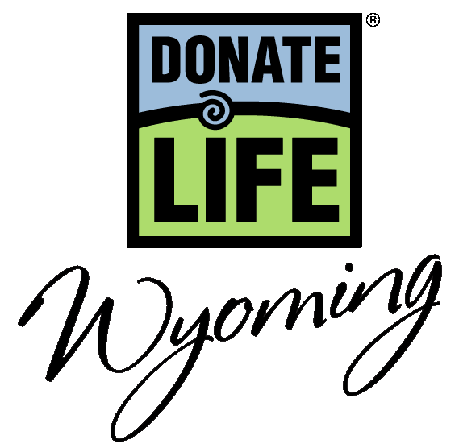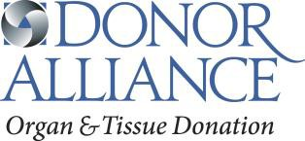

National Donate Life Month 2019 – General PSA Scripts

:10 (27 words)
Show Your Heart for National Donate Life Month this April. Be someone’s Hero and show your support for organ, eye and tissue donation. Learn more at DonateLifeWyoming.org/ShowYourHeart.

:15 (45 words)
Show Your Heart for National Donate Life Month this April! Nearly 150 people in Wyoming continue to wait for a lifesaving transplant. Be someone’s Hero by saying Yes to organ, eye and tissue donation. Learn more on how to show your support at DonateLifeWyoming.org/ShowYourHeart.

:30 (82 words)
Show Your Heart in support of organ, eye and tissue donation during National Donate Life Month this April! Nearly 150 people in Wyoming continue to wait for a lifesaving transplant and everyone, regardless of age or medical condition, can sign up as a donor. Be someone’s Hero by saying Yes to organ, eye and tissue donation at the Driver License Office. Once you’ve signed up and discussed donation with your family, you can learn more on how to show your support at DonateLifeWyoming.org/ShowYourHeart.

National Donate Life Month Show Your Heart and Save – PSA Copy

:10 (31 words)
Show Your Heart for National Donate Life Month! This April, show the hearts on your driver license at participating theatres and get a free popcorn! For more information, visit DonateLifeWyoming.org/ShowYourHeart.

:15 (43 words)
Show Your Heart for National Donate Life Month! This April, show the hearts on your driver license at participating theatres and get a free popcorn! Saying yes to organ, eye and tissue donation saves lives. Learn more at DonateLifeWyoming.org/ShowYourHeart.

:30 (89 words)
Show Your Heart and Save for National Donate Life Month! This April, show the hearts on your driver license or one of our inspirational hearts at participating theaters and get a free popcorn! Show your support for the nearly 150 people in Wyoming waiting for a lifesaving transplant with the hashtag #ShowYourHeart. Be someone’s Hero. Saying yes to organ, eye and tissue donation saves lives. For more details and to learn how you can be someone’s hero visit DonateLifeWyoming.org/ShowYourHeart or search #ShowYourHeart.

