Stefan Wilson
Donor Brother
Colorado

“I saw the accident on TV,” said Stefan Wilson, of his late brother, Justin Wilson. Stephan, a driver for Andretti Autosport, was visiting his brother’s home in Colorado, when Justin was fatally struck by debris during a race. Justin Wilson passed away the following day.

Justin participated in eight Indy 500s, had 120 career IndyCar starts and 54 races in Champ Car. Even with all of his racing success, Justin’s family was not prepared for the impact of his passing. Stefan remembers that difficult moment at the hospital in August of 2015 when doctors informed them of Justin’s wishes to be a donor. Stefan and family were proud of Justin’s decision, and through organ donation Justin saved the lives of five people in need.

Stefan has made a name for himself in motorsports. In 2007, he earned the McLaren Autosport BRDC Award for promising British drivers after he finished second in the Formula Palmer Audi Championship. In 2011, he won two races with Andretti Autosport. Stefan feels like he is racing for his brother as much as he is racing for himself. He wants to succeed in his own career, but he also wants to have a long racing career as Justin never got the chance.

Stefan continues to honor his brother’s choice to be an organ, eye and tissue donor by raising awareness for the cause. Stefan regularly participates in events focused on motivating people to register and sharing that donation saves lives.

“Out of all the accomplishments my brother had on [the] track, there’s nothing more impressive than actually saving five human beings – there’s five people on this earth right now that wouldn’t be here without Justin.”
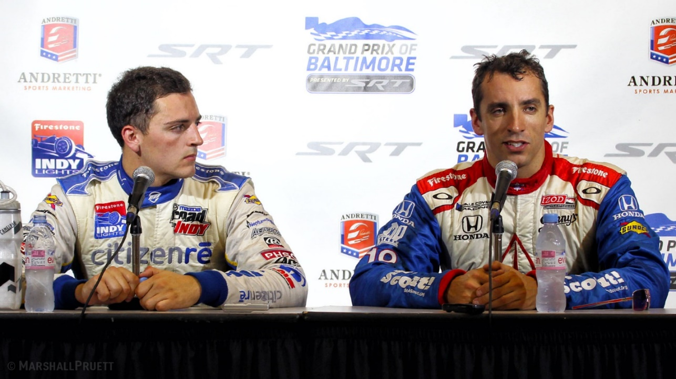
Stefan and Justin Wilson

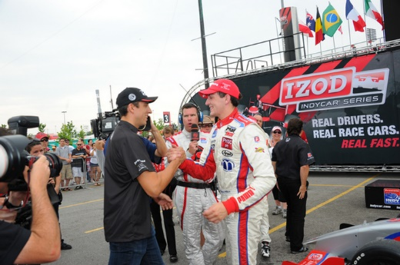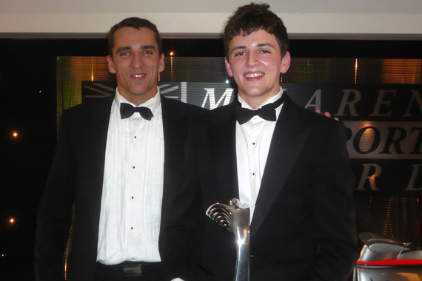
Stefan and Justin Wilson Stefan and Justin Wilson

