Gaby
Donor Sister
Denver, CO

Gaby’s life changed when her younger sister Diana passed away in a tragic automobile accident at the age of 16. She describes that day as one of the most difficult times for her and her entire family. At that difficult time, the Landeros family decided to donate Diana’s organs as a way to honor her memory and help somebody else in need. Diana is described by her family and friends as a caring and loving person who enjoyed helping people in any way she could, so donating her organs to help somebody else felt like a natural thing to do.
During those difficult moments, the Landeros family found some comfort in knowing that Diana’s legacy will continue through the gift of organ, eye and tissue donation. Thanks to Diana’s gifts, three people were given a second chance at life, including a young girl in Missouri.
Because of her connection to donation, Gaby became a passionate advocate for organ, eye and tissue donation. She has volunteered with Donor Alliance for more than three years to honor the memory of her sister and raise awareness about the lifesaving gift of donation and transplantation. Gabriela believes it is important for all families to discuss organ and tissue donation, and recognizes that is especially important for Hispanic families to learn the facts about donation and transplantation and register as donors.
Here in our community, there are nearly 2,000 people waiting for a lifesaving organ transplant. Anyone can sign up to be an organ, eye and tissue donor regardless of age or medical condition. This is easy to do by saying Yes at the driver license office or anytime at DonateLifeColorado.org.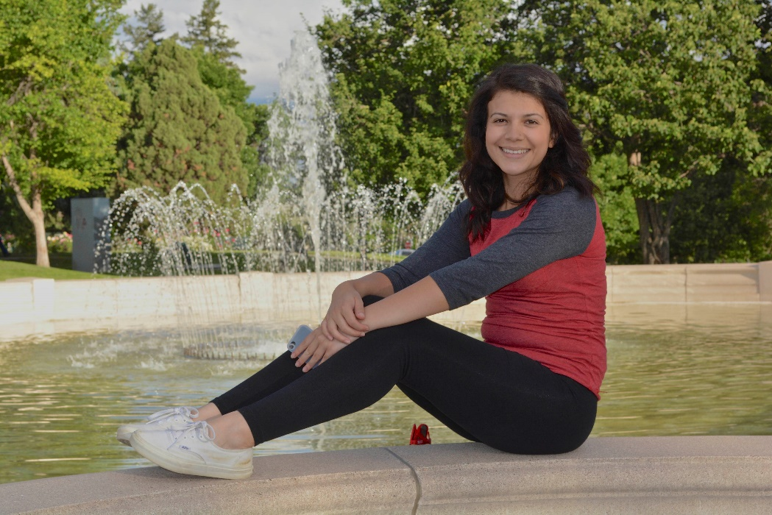
Gaby

