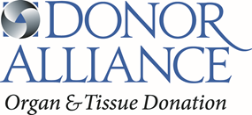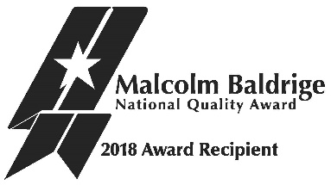
Baldrige Sharing Day
8:30 AM - 9:00 AM | Breakfast & Networking
9:00 AM - 9:20 AM | Welcome & Overview  Sue Dunn, President/CEO
9:20 AM - 9:40 AM | Connect to Mission  Colleen Reed, Organ Transplant Recipient
How the Baldrige Framework Drives Performance
9:40 AM - 10:40 AM | Category 2: Strategic Planning Process  Jennifer Prinz, COO  Laura Jeffries, Director of Human Resources  Steve Selby, Director of Information Systems
10:40 AM - 10:50 AM | Break
10:50 AM -11:20 AM | Category 3: Customer Focus  Jay Ruterbories, Director of Organ Procurement  Steve Mansfield, Director of Tissue Services | Category 5: Workforce Focus  Laura Jeffries, Director of Human Resources  Andrea Smith, Director of Communications/PR
11:20 AM - 11:25 AM | Break
11:25 AM - 11:55 AM  30 min | Category 5: Workforce Focus  Laura Jeffries, Director of Human Resources  Andrea Smith, Director of Communications/PR | Category 3: Customer Focus  Jay Ruterbories, Director of Organ Procurement  Steve Mansfield, Director of Tissue Services
11:55 AM -1:10 PM | Lunch  Schwartz Rounds: The Baldrige Journey
1:10 PM - 1:25 PM | Break
1:25 PM - 1:55 PM | Category 6: Operations Focus  Recovery Center Tour  Grace Harcek, Director of Performance Excellence  Kim Robuck, Hospital Development Manager | Category 1: Leadership  Sue Dunn, President/CEO  Jennifer Prinz, COO
1:55 PM - 2:25 PM |  | Category 4: Measurement, Analysis, & Knowledge Management  Steve Selby, Director of Information Systems  Niki Titsworth, Organ Recovery Manager
2:25 PM - 2:40 PM | Break
2:40 PM - 3:10 PM | Category 1: Leadership  Sue Dunn, President/CEO  Jennifer Prinz, COO | Category 6: Operations Focus  Recovery Center Tour  Grace Harcek, Director of Performance Excellence  Kim Robuck, Hospital Development Manager
3:10 PM - 3:40 PM | Category 4: Measurement, Analysis, & Knowledge Management  Steve Selby, Director of Information Systems  Niki Titsworth, Organ Recovery Manager
3:40 PM - 3:50 PM | Closing Remarks  Sue Dunn, President/CEO
4:30 PM – 6:30 PM | Social Event  The Tavern

