**Donor Alliance National Donate Life Month Sample Social Media Post Copy 2023**

**Facebook/Instagram Post**

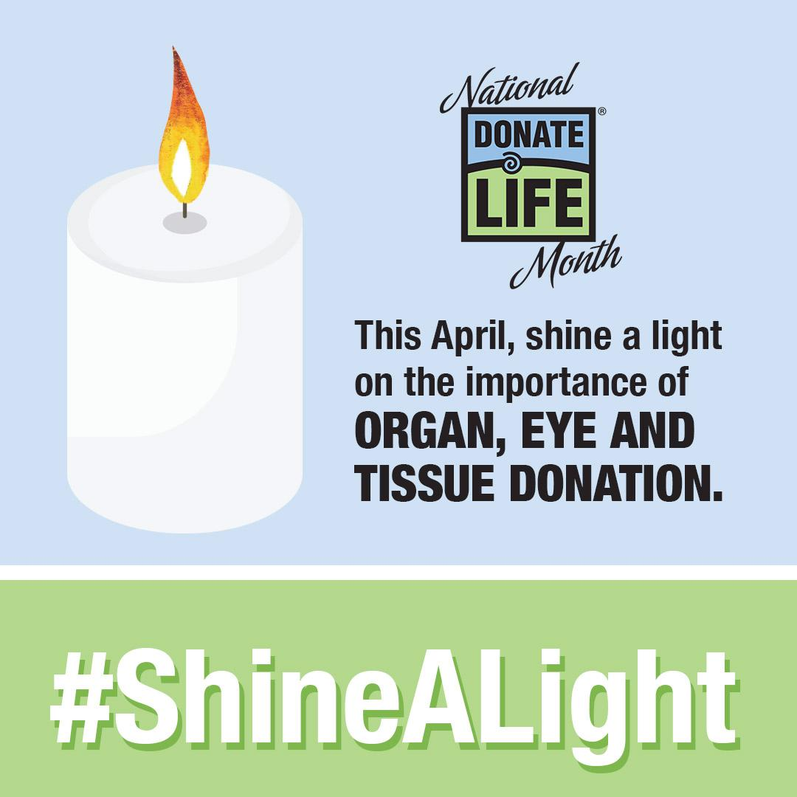

***Colorado***

Join us in celebrating National Donate Life Month this April! With nearly 1,500 people needing a lifesaving transplant right now, it’s important to shine a light on saying “Yes” to organ, eye and tissue donation.

This month we have free #ShineALight kits that include a candle to place in your window for everyone to see. The light serves as a symbol of hope as we honor the donors’ generous gift of life.

This month, celebrate with the recipients of lifesaving transplants and take a moment to recognize the Coloradans waiting today. Request your free kit at DonateLifeColorado.org/ShineALight.

***Wyoming***

Join us in celebrating National Donate Life Month this April! With nearly 1,500 people needing a lifesaving transplant right now, it’s important to shine a light on saying “Yes” to organ, eye and tissue donation.

This month we have free #ShineALight kits that include a candle to place in your window for everyone to see. The light serves as a symbol of hope as we honor the donors’ generous gift of life. This month, celebrate with the recipients of lifesaving transplants and take a moment to recognize the Wyomingites waiting today.

Request your free kit at DonateLifeWyomingorg/ShineALight.

**Twitter Post**

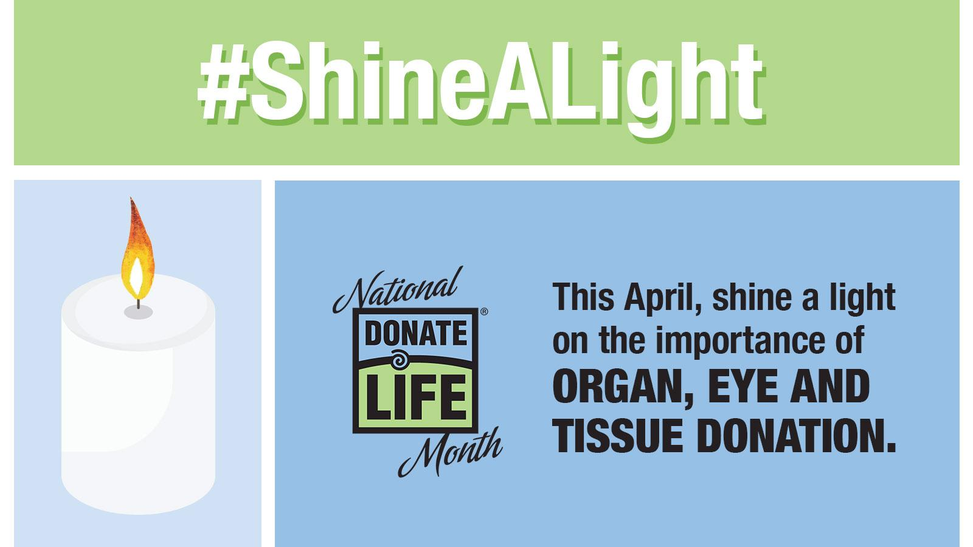

***Colorado***

Celebrate #DonateLifeMonth by recognizing the nearly 1,500 Coloradans waiting for life-saving transplants. Get a #ShineALight kit with a candle to display in your window as a symbol of hope. Request your free kit at DonateLifeColorado.org/ShineALight).

***Wyoming***

Celebrate #DonateLifeMonth by recognizing the nearly 1,500 Wyomingites waiting for life-saving transplants. Get a #ShineALight kit with a candle to display in your window as a symbol of hope. Request your free kit at DonateLifeWyoming.org/ShineALight.