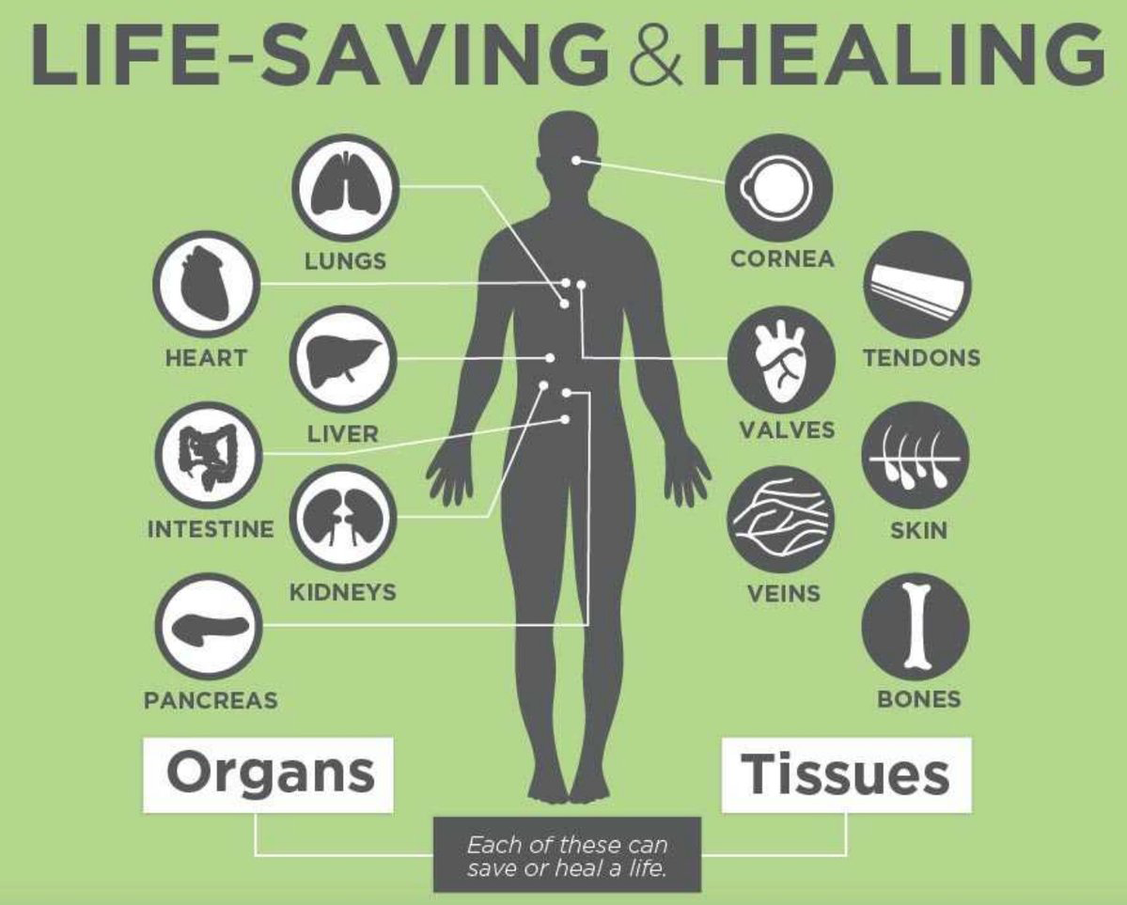  organ donor referral  ventilated  With a loss of 2 or More Brain Stem Reflexes and/or Glasgow Coma Scale of ≤ 5 and/or  Family Discussing End-of-Life Options and/or Family Brings up Donation  never bring up donation  What you can say…  “Someone who works with our hospital will be coming to speak with you about some further end-of-life options."  (303) 329-4747 | WHAT ELSE DO I NEED TO KNOW?  Law protects an individual’s right to designate themselves as a donor on the Donor Registry  ────  Hospital must keep the patient stable until OPO can evaluate and approach the family if medically suitable  ────  Coroner and hospital must collaborate with OPO so individuals have the opportunity to donate  ────  Regulatory agencies require that only those who have had certified training may discuss donation with families  TISSUE REFERRAL  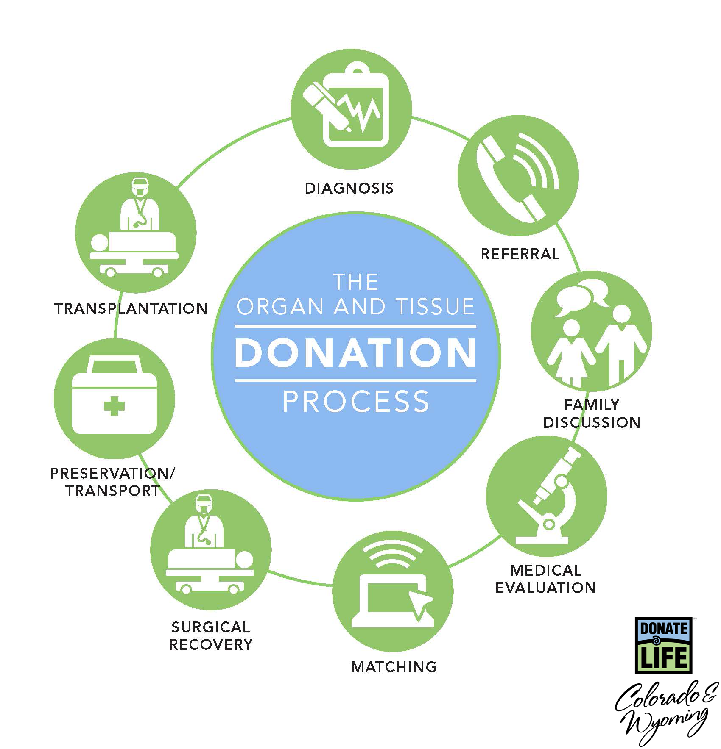  Call within 60 minutes of every death
Referral: (800) 448-4644

