How to Use the National Donate Life Month PR Flyer

Customization:
- Photos
  - Photos can be customized with local photos.
  - You can customize the photos through the Microsoft Word file by right clicking on an image and then selecting “change picture”. You can then select any photo from your computer to insert.
  - Once inserted, photos will likely need to be sized to fit the pre-existing area.
  - However, the given fliers are only meant to be templates. Users may feel free to rearrange the order of photos, their shapes and/or sizes.
- Text
  - Please refrain from changing the text, except for inserting your library’s name and individual event details.
  - Flyers may be used as an illustrative/visual Press Release to be handed out, printed and hung, etc. to advertise National Donate Life Month.
  - Text can be customized where indicated to include information regarding library activities honoring NDLM, contact information, and/or state registry information.
  - Each photo has a letter associated with it (i.e. A, B, C…) that corresponds to the local event that is listed if the user wishes. If the user does not plan on listing local events or simply does not want to have the letters appear on the photos, they can be deleted. Delete this text by clicking on the letter to highlight. Then, right click and select cut.
Where and How to Use:
  - Flyers can be printed and displayed or passed out as a visual representation of National Donate Life Month and the information included in the official press release.
  - They can also serve as a reminder for the activities/events that will be held locally in support of National Donate Life Month
  - Fliers can be dispersed electronically through e-mail as a PDF file or converted to an image file (JPG, PNG, etc.) to post on social media pages like Facebook, Twitter, or Foursquare.

For questions on how to use the PR Fliers or what to include, please contact:
  - Kathryn Cicerchi, kcicerchi@donoralliance.org


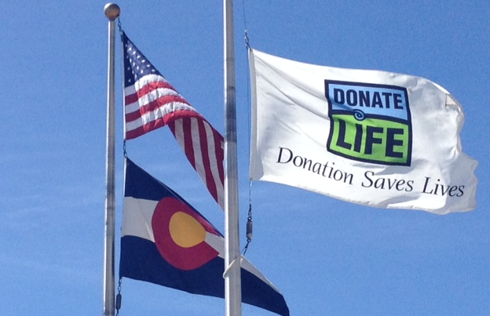
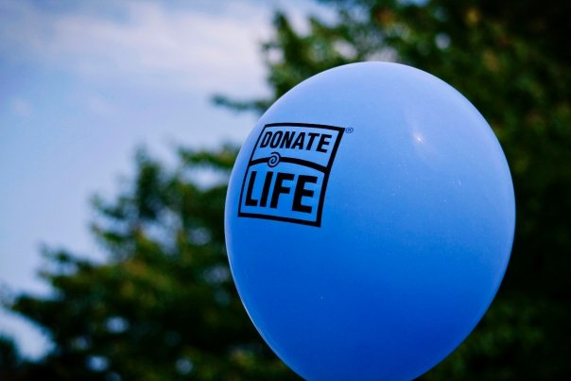


C

Donate Life, Colorado!

National Donate Life Month 2015
Our library is proud to celebrate April as National Donate Life Month! This month-long celebration honors the generosity of organ and tissue donors and their families and commemorates all transplant recipients in the United States. As part of our celebration, Donate Life Colorado/Wyoming and [INSERT LIBRARY NAME] acknowledge the importance of educating communities nationwide about the renewing power of donation and encouraging them to register as organ, eye and tissue donors.
Please join [INSERT LIBRARY NAME] for these activities!

[Insert local event A]
Insert description of local event…

[Insert local event B]
Insert description of local event…
[Date: xx/xx/xxxx]
[Date: xx/xx/xxxx]

[Insert local event C]
Insert description of local event…
[Date: xx/xx/xxxx]

A

B

