Social Media Copy

Facebook #1
Do you have the heart on your driver’s license? How did you make the decision to save lives by being an organ & tissue donor? Why do you think it is important to be an organ & tissue donor? Learn more about how you can help the 2,700 people waiting for a lifesaving transplant in Colorado and Wyoming - http://www.donatelifecolorado.org/understanding-donation/

Facebook #2
Know anyone who’s had or is in need of a lifesaving transplant? More than 2,500 people are waiting right here in Colorado. Read the stories of a few Coloradans who’ve been saved by a transplant and the amazing donors who said yes to organ and tissue donation http://www.donatelifecolorado.org/stories-of-hope/

Facebook #3
Did you know anyone can register to be a donor regardless of age or health? Even diabetics and others with chronic diseases have the power to donate life. April is National Donate Life Month. Celebrate by sharing your support of giving the gift of life. #DonateLife

Facebook #4
More than 108,000 people are in need of a lifesaving kidney transplant in this country. Would you ever consider being a living donor and giving one of your kidneys to someone in need?

Facebook #5
Photo post:
Diagnosed with a rare liver disease as an infant, Vienna is now a spunky, out-going 10 year old because her hero said yes! Her mom says, "We are so grateful to our donor's family. Because of his gift, I get to kiss a miracle every day." Read her story at http://www.donoralliance.org/recipients/Vienna/. (Vienna image attached)
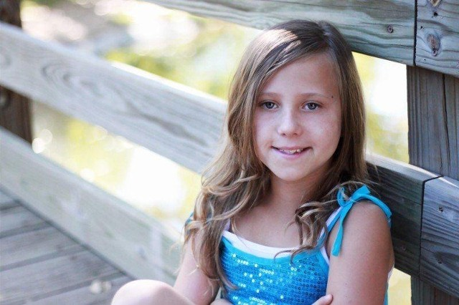

Twitter

Twitter #1
2,700 people in Colorado are waiting for a lifesaving transplant. You can help - register as an organ & tissue donor. @DonateLifeCO

Twitter #2
A mother can “kiss a miracle every day” because her daughter’s hero said yes. Her story:http://bit.ly/1QpDAiR #DonateLife @DonateLifeCO

Twitter #3
Did you know 68% of Coloradans are registered organ, eye and tissue donors? More than almost any other state! #DonateLife @DonateLifeCO

Twitter #4
Would you ever consider being a living kidney donor? More than 108,000 are in need in the U.S. @DonateLifeCO

Twitter #5
Tissue donation is just as important as organ donation! Millions of lives are saved & healed w tissue each year. #DonateLife @DonateLifeCO

Twitter #5
#DidYouKnow? You can renew your #CO driver's license (& register as an organ & tissue donor while you do) any time @ https://www.colorado.gov/pacific/dmv

Twitter #5
The most common myths about organ & tissue donation in #Colorado, debunked: http://www.donoralliance.org/why-donate/donation-myths-facts/ #DonateLife Please ReTweet!

Feel free to use these photos for any posts as well…

