Nieves, Kidney Recipient
Alamosa, CO

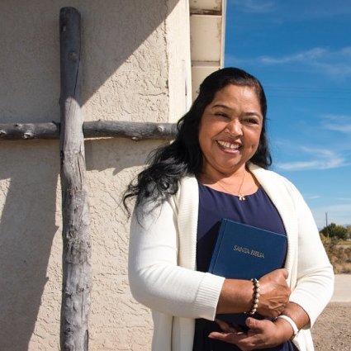
After being diagnosed with kidney disease, Nieves was on dialysis for four years when her sister offered to be a living donor and give her one of her kidneys. Nieves’ sister was a match, but was told by her doctor that she needed to lose weight before she would be able to donate her kidney. After almost a year, Nieves’ sister was able to lose the weight, but due to health complications was no longer a viable donor.

After hearing the bad news Nieves was disappointed and saddened, but she had faith, she put her trust in God and decided to ask her doctor if she could get placed on the transplant waiting list. After being on the list for a year, Nieves received the call that a kidney had become available. In October 2013, Nieves’ daughter and son-in-law drove her from Alamosa to the University of Colorado Hospital in Aurora, CO but when they got there, Nieves was told there was something wrong with the kidney and it was no longer viable for a transplant. They were on their way back to Alamosa after hearing the bad news, when Nieves got another call from the transplant center. Another kidney had become available and seemed to be a perfect match. They returned to the hospital and Nieves’ long-awaited transplant finally took place.

“It has been almost three years since my transplant and I’m doing really well. My family and I are so very grateful to my donor family and to God for giving me a second chance at life. I am now able to enjoy time with my family, go to church and care for my grandchildren.”

